**07 – Boundary Conditions**

**Topics:** Boundary conditions, Maxwell’s equations in integral form.

**Summary:** These activities guide students through a derivation of the boundary conditions on the electric and magnetic fields at the interface between vacuum and a general material. Initial tasks have them consider the charge/current/flux enclosed by imaginary surfaces. They are then guided to apply Maxwell’s equations to solve for the conditions on the fields at either side of the boundary.

**Written by:** Charles Baily, Michael Dubson and Steven Pollock.

**Contact:** Steven.Pollock@Colorado.EDU

**Comments:** Most students should be able to complete this activity in less than 50 minutes. In the interest of time, the Gaussian surfaces and Amperian loops are given to students; we notice they may still have persistent difficulties in generating them on their own, but this can be addressed separately, or the relevant pages could be altered to require this. Just prior to implementation, we gave our class a brief review of sign conventions regarding unit vectors and integration surfaces/loops. During the tasks, many students were still introducing minus signs into the equations from memory (or intuition), without being able to justify them in terms of the direction of the unit vectors. Some students are confused by the distinction between a *surface* current and the *volume* current “right at the very edge” of a material, and this is addressed by having them consider the charge/flux enclosed by surfaces with dimensions that shrink to zero, in this case just across the surface. Allowing the fields to have spatial dependence, and then shrinking the surfaces along all three dimensions would add a layer of complexity and require more time; the reasons are the same for not using an interface between two general media. Some students surprisingly got very caught up on whether the charge/current/flux enclosed is actually zero, or just vanishingly small – this can be an opportunity to discuss comparisons between finite quantities and ones that are differentially small. We have purposefully avoided reference to the auxiliary fields  and , and there is no distinguishing here between free and bound charges/currents, again because of the added complexity. The resulting boundary equations therefore appear slightly different than how they are written in Griffiths (derived using the auxiliary fields), but the derivations herein follow the same general procedure – instructors may want to call attention to this. The tasks become progressively less explicit on the procedure to be followed, with the intention being for students to recognize that the same general procedure is applied in every case. For those who are quick to finish the tasks, a potential *challenge question* would be to have them re-derive the boundary conditions for the more general case of two different media, possibly also using the auxiliary fields.

**A.** Consider the interface shown in the diagram below, between vacuum (region **1**) and some kind of material (region **2**). In region **2** there is a uniform *volume* charge density , and there is also a uniform *surface* charge density  on the boundary between the two regions.

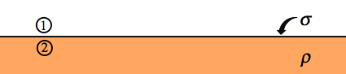

A cylindrical Gaussian surface (dashed lines, below) encloses a volume entirely inside region **2**. The ends have circular area **A** and the cylinder has height  ( is measured from the midpoint). In the limit that , what is the *total charge* enclosed by this Gaussian surface? Briefly explain your reasoning.

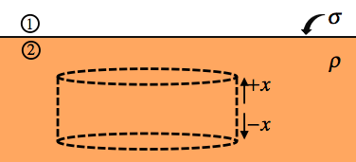

In the same situation as above, suppose the Gaussian surface is drawn so that it now straddles the interface (partly inside region **1**, partly inside region **2**). In the limit that , what is the *total charge* enclosed by this Gaussian surface? Briefly explain your reasoning.

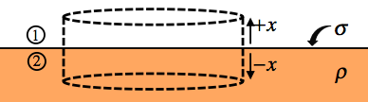

**B.** Imagine now there are spatially uniform electric fields just above () and just below the surface of the material (). The field  is uniform within region **1**, and  is uniform within region **2**, but they are not necessarily equal.

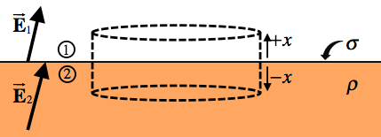

Let the distance  shrink to zero in the Gaussian surface above, and use Gauss’ law:



to find an equation that relates the *perpendicular* component of the E-field in region **1** to the *perpendicular* component of the E-field in region **2**. Be sure to identify any unit vectors that are relevant.

**C.** Suppose the vectors in the diagram above *instead* represented spatially uniform *magnetic* fields  (just above the surface) and  (just below). What would be the analogous boundary condition on the perpendicular components of the magnetic fields in each region? [Hint: What is Gauss’ law for magnetic fields?]

**D.** Suppose that now, in addition to the same electric fields  & , there are time-dependent, spatially uniform magnetic fields  and  (above and below the surface), both pointing out of the page at the time considered.

A rectangular Amperian loop (dashed lines, below) has length  and width  ( is measured from the midpoint), and is drawn so that it straddles the interface. The arrows along the loop represent the direction to be used for any line integrals.

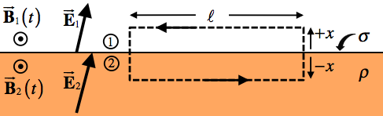

In the limit that , what is the total magnetic flux through the area enclosed by this Amperian loop? Briefly explain your reasoning.

Let the distance  shrink to zero for the Amperian loop above, and use Faraday’s law:



to find an equation that relates the *parallel* component of the E-field in region **1** to the *parallel* component of the E-field in region **2**. Be sure to identify any unit vectors that are relevant.

**E.** Imagine the same kind of interface between vacuum (region **1**) and a material (region **2**). Inside region **2** there is now a uniform volume *current* density , and a uniform surface *current* density  on the boundary, both pointing out of the page.

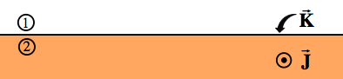

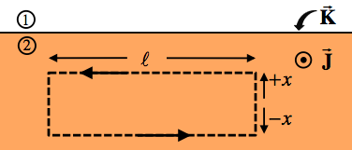A rectangular Amperian loop with length  and height  (dashed lines) encloses an area entirely inside region **2**. In the limit that , what is the total current enclosed by this Amperian loop? Briefly explain your reasoning.

In the same situation as above, suppose the Amperian loop is drawn so that it now straddles the interface. In the limit that , what is the total current enclosed by this Amperian loop? Briefly explain your reasoning.

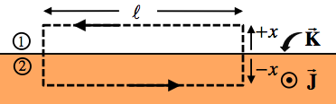

**F.** Suppose there are now uniform magnetic fields  and , both pointing to the right. There are also time-dependent, spatially uniform electric fields  &  pointing *out* *of* *the* *page* at the time considered.

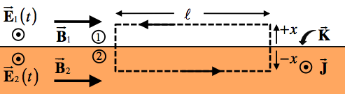

For this situation, use the Maxwell-Ampere law:



to determine the boundary condition on the components of  that are parallel to the interface. Briefly explain each of your steps in words.